**Naïve Bayes Classification**

This assumes that the presence of a certain feature in a class is independent of the presence of other features. EX: fruit can be classified as watermelon if its color is green, tastes sweet and round, but these features could be depending on each other. But we are assuming they are independent and that's why the name came as 'Naive'.

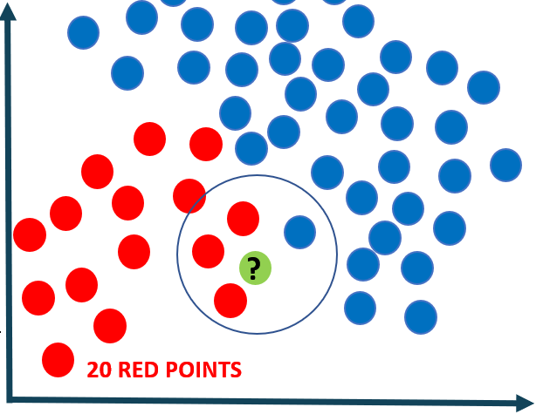

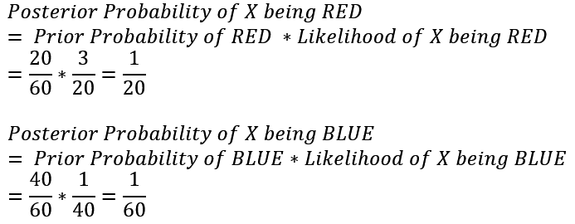

Prior probability = Total number of red points/Total number of points

Posterior probability = Number of red points in the vicinity /Total number of red points

